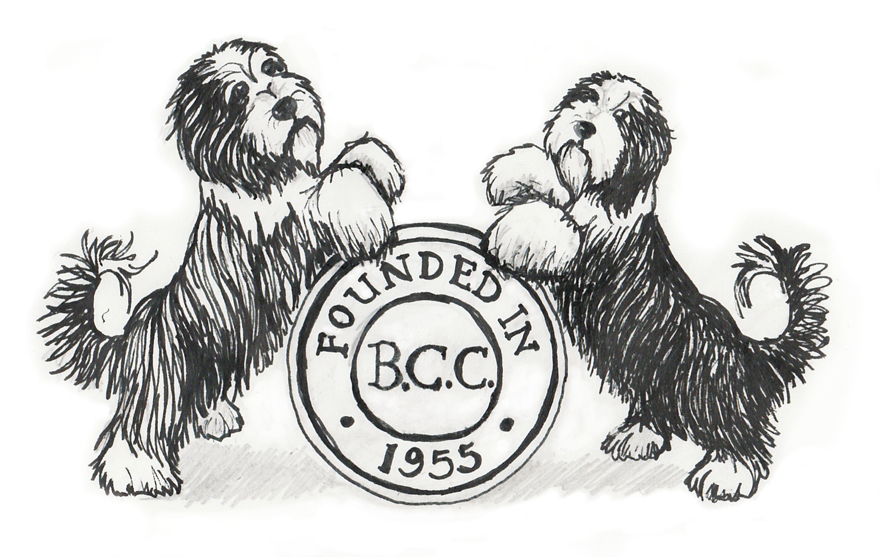
THE BEARDED COLLIE CLUB

Qualifications for the Club's Judging Lists

A1 List

For persons who have previously been approved by the Kennel Club to award CCs in the breed and have completed their first appointment. To have the support of the Bearded Collie Club.

A2 List

For persons who fulfil all the requirements for the A3 list and who have been assessed in accordance with Kennel Club requirements and accepted by the Kennel Club for inclusion on an A2 list and have the support of the Bearded Collie Club.

A3 List (Breed Specialists)

Applicants must fulfil the following qualifications:

- Have been on any Bearded Collie Club Open Show List for at least three years or already be approved by the Kennel Club to award Challenge Certificates in the breed. Minimum of 7 years judging the breed and have the support of the Bearded Collie Club.
2 Have judged at least 40 classes of Bearded Collies in at least 8 separate Open Shows with a minimum of 120 dogs present in the classes, and an adequate geographical spread.
4 To have stewarded over a minimum of 12 days at shows.
5 Have bred and/or owned a minimum of 3 Bearded Collies when they obtained their 1st entry in the Kennel Club Stud Book (save in exceptional circumstances).
6 To have attended a seminar given by a Kennel Club Accredited Trainer and passed the relevant examination on the Requirements of a Dog Show Judge.
7 To have attended a seminar given by a Kennel Club Accredited Trainer on Conformation and Movement.
8 To have attended at least one Bearded Collie club breed specific seminar run in accordance with the relevant Kennel Club Code of Best Practice and passed a written examination and practical assessment.
9 To have attended a 'Points of the Dog' assessment conducted by a Kennel Club Accredited Trainer and passed the assessment.

A3 List (Non Specialists)

Applicants must fulfil the following qualifications:

1 Minimum of 7 years judging experience in any one breed (to include 5 years in Bearded Collies) and have the support of the Bearded Collie Club.
2 Have judged at least 40 classes of Bearded Collies in at least 8 separate Open Shows with a minimum of 120 dogs present in the classes, and an adequate geographical spread.
3 Have awarded CCs in at least one other breed.
4 To have bred or qualified three dogs for the Kennel Club Stud Book (save in exceptional circumstances).
5 To have attended at least one Bearded Collie club breed specific seminar run in accordance with the relevant Kennel Club Code of Best Practice and passed a written examination and practical assessment.

Please Note: Our B List Criteria is such that successful applicants will be considered eligible to judge at our Club Open shows and we will automatically consider those who do not meet our ‘B’ list criteria for the C/JEP Level 1 List.

Judging Criteria for B Lists
Indicates persons who have been approved by the Bearded Collie Club to judge the breed at Breed Club Open Shows, General Open Shows or at Championship Shows (without CC’s) for an unlimited number of classes for the breed.

B List (Breed Specialists)

To meet the requirements of JEP Level 2, namely:
• Minimum of 5 years proven interest in pedigree dogs
• Attend a Conformation and Movement seminar hosted by a Kennel Club Accredited Trainer
• Complete a minimum of two full-day stewarding appointments
• Attend a Requirements of a Dog Show Judge seminar and pass associated exam (either in person or online via Kennel Club Academy, exam effective from 1 January 2024)
• Pass the Points of a Dog assessment conducted by a Kennel Club Accredited Trainer (effective from 1 January 2024)
• Attend a Breed Appreciation day (BAD) and pass a multiple-choice examination (MCE) for Bearded Collies
• View Ring Stewarding Seminar and take online quiz
• Complete critique writing seminar and take online quiz.

Together with the following:

• Have owned &/or handled Bearded Collies for 5 years
• Have judged a minimum of 40 Bearded Collies in total in Breed Classes, in at least 2 licenced shows, with ideally an adequate geographical spread and have the support of the Bearded Collie Club.

B List (Non Specialists)

To meet the requirements of JEP Level 2, namely:
• Minimum of 5 years proven interest in pedigree dogs
• Attend a Conformation and Movement seminar hosted by a Kennel Club Accredited Trainer
• Complete a minimum of two full-day stewarding appointments
• Attend a Requirements of a Dog Show Judge seminar and pass associated exam (either in person or online via Kennel Club Academy, exam effective from 1 January 2024)
• Pass the Points of a Dog assessment conducted by a Kennel Club Accredited Trainer (effective from 1 January 2024)
• Attend a Breed Appreciation day (BAD) and pass a multiple-choice examination (MCE) for Bearded Collies (Note: Not mandatory for group judge for breeds in the group that they are not approved at level 4, but attendance strongly recommended)
• View Ring Stewarding Seminar and take online quiz
• Complete critique writing seminar and take online quiz.

Together with the following:
• Have had a minimum of 5 years judging experience, including 3 years experience of judging Bearded Collies and have the support of the Bearded Collie Club.
• Have judged a minimum of 40 Bearded Collies in total in Breed Classes, in at least 2 licenced shows, with ideally an adequate geographical spread and have the support of the Bearded Collie Club

C List (JEP Level 1 List)

For aspirant judges who have shown an interest in the breed and have the support of the Bearded Collie Club and do not yet qualify for the Clubs JEP Level 2 (B List for Specialists and Non Specialists)

Judges on this list must meet the JEP Level 1 requirements (below) and will be eligible to judge up to 3 classes (4 if one is a puppy class) for any breed at limited or Open Shows.

• Minimum of 5 years proven interest in pedigree dogs
• Attend a Conformation and Movement seminar hosted by a Kennel Club Accredited Trainer
• Complete a minimum of two full-day stewarding appointments
• Attend a Requirements of a Dog Show Judge seminar and pass associated exam (either in person or online via Kennel Club Academy, exam effective from 1 January 2024)
• Pass the Points of a Dog assessment conducted by a Kennel Club Accredited Trainer (effective from 1 January 2024)

NOTE: Overseas equivalents will be considered where appropriate. Club Judging Lists will be reviewed on an annual basis. Judges failing to provide a written critique may be withdrawn from the list.

If you wish to apply for the A or B judging lists, or if you are interested in being assessed for the A2 list, you can contact the Secretary of the Judges’ Sub-Committee, contact details below.

To be considered for any list, you will be required to complete a Bearded Collie Club 'Judges List Questionnaire'. Questionnaires are available via the Club website: www.beardedcollieclub.co.uk/downloads.php

or from the Judges’ Sub-Committee Secretary:

Miss Laura Jay
Blacksmiths Cottage
Barton le Willows
York
YO60 7PD

Tel: 07727 634589
email: laura_jay2000@hotmail.com

(Revised July 2025)

